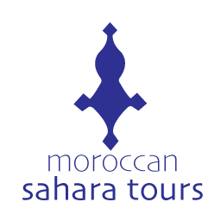
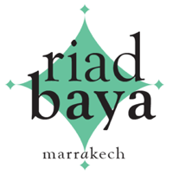
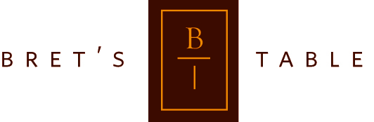

2026 Discover Morocco with Bret’s Table
11 – 22 November 2026
with Moroccan Sahara Tours and Riad Baya

Be part of an extraordinary adventure! Join Bret’s Table, Moroccan Sahara Tours, and Riad Baya for an unforgettable journey discovering the vibrant colors, aromatic spices, and the rich traditions of Morocco.

While we discover the beauty of Morocco during our adventure, we will also experience the welcoming embrace of the Moroccan people with their warm and friendly smiles.

This 11-day adventure immerses travelers in the culture, cuisine, and landscapes of this enchanting country from the bustling cities and charming villages to the golden dunes of the Sahara Desert.

Travel in comfort in a temperature-controlled coach, learn from expert guides, and savor authentic Moroccan flavors through cooking classes, market tours, and a winery experience as we explore together the heart of North Africa. Plus, there will also be plenty of time to explore on your own.

WHERE YOU WILL STAY
We will spend several nights at an amazing riad nestled in Marrakech’s historic medina.

Riads are works of art that have been restored and transformed into luxurious guest houses, featuring lush courtyards, often with a plunge pool, a spacious roof-top sun terrace, and well-appointed rooms.

Your Riad will be in the historic Medina of Marrakech and a short stroll to major attractions and shops.

DAY TRIPS & EXCURSIONS
Morocco is a feast for the senses. Imagine a cacophony of sounds and aromas with street vendors bartering their wares and fragrant conical towers of spices piled high.

During our time together, we will pass through the Atlas Mountains, exploring villages along the way. It will culminate in one spectacular night with dinner, stargazing and finally sleeping in luxury tent accommodations in the desert.

We’ll pass through the highest pass in North Africa, the Tichka Pass, visiting historic sites and villages along the way. It’s a beautiful, mountainous area with breath-taking views.

Stopping on the spur of the moment is part of the excitement especially when our guide sees something unique or interesting like a roadside vendor selling hand-crafted rugs or women working in the field, or steaming hot bread being sold from a communal oven, or a group of children playing football.

It's an intoxicating country, and our guide and associates are thrilled to share with you their unique perspectives during this amazing tour, one you will not find on other tour sites.

COOKING CLASSES
Moroccan cuisine is as sophisticated and diverse as its aromas and flavors. It holds an enduring legacy, with a blend of Amazigh (Berber) roots, along with staples like couscous and tagines.

Each region has its own specialty. We will experience many of these unique dishes and even learn how to make some of them.

Food influences in Morocco come from Arab, Andalusian, Jewish, and European cultures. The Arabs introduced key spices like cinnamon, ginger, and saffron, while Jewish migrants brought pickling and preservation techniques, influencing ingredients like preserved lemon.

European influences, especially French and Spanish, also added new culinary techniques and flavors over time.

We’ll enjoy hands-on and/or demonstration cooking classes where you will learn how to combine spices, fresh ingredients, and simple techniques to create delicious dishes to share with friends and family at home.

WHAT’S INCLUDED
- All accommodations including in the Sahara Desert
- Hands-on and/or demonstration cooking classes afterwards enjoying our meal together
- Winery experience with lunch
- Excursions and day trips with knowledgeable and friendly multilingual guides with private coach transportation
- Transfer from / to Marrakech Menara Airport (RAK) to our Riad
- Breakfast every morning, including a variety of pastries and breads, specialty egg dishes, yogurt, cheese, olives, fresh orange juice, coffee, mint tea.
- A more detailed Itinerary upon request.

NOT INCLUDED
- Airfare
- Tips to our drivers, guides, and guesthouse staff
- Beverages (sold at the Riad and along the way)
- Laundry services in Marrakech
- Entrance fees to attractions (nominal)
- Add-on experiences and excursions to gardens, individual guided tours (during your free time) and museums
- Lunches and Dinners not specified
- Refunds for previously planned and paid activities, accommodations, or day trips not completed for any reason

TRIP COSTS
- The price for this Bret’s Table Culinary Tour is $5,250.00 USD per person, based on double occupancy. Limited single-occupancy rooms are available.
- A single supplement charge of $500.00 USD for solo travelers.
- A non-refundable deposit of $500 USD per person is required to reserve the travel dates.
- First payment Installment due: March 1, 2026 - $2,750.00 USD (non-refundable)
- Final payment Installment due: June 1, 2026 - $2,000.00 USD (non-refundable)

PAYMENT OPTIONS
- Zelle: bretbannon@bretstable.com
- Checks made out to Bret Bannon with a note on the check: “Bret’s Table Moroccan Tour”, 1805 Randolph Ave, Saint Paul MN 55105

